Chapter
Product Design

Discussion Questions
1. Explicit documentation accomplishes two things:
(a) It provides the information necessary to produce (capacity, training, routing, costs, etc.) the product in the appropriate fashion
(b) If the product we produce does not perform as we anticipated, the documentation provides the basis for finding and correcting the problems in a logical manner.
2. Product definition includes engineering drawings, written specifications, bills-of-material, formulas, storyboards, portion control documents, scripts, insurance policies, etc.
3. Investment, market share, product life cycle, and breadth of the product line are all linked to the product decision.
4. Once a manufactured product is defined, the documents used are:
■ assembly drawings
■ assembly charts
■ route sheets
■ job instructions
■ standards manuals
■ work orders
5. Time-based competition uses a competitive strategy of getting products to market rapidly and may include rapid design, efficient delivery systems, and JIT manufacturing.
6. Joint ventures are combined ownership between two firms to form a new entity with a new mission. Alliances are cooperative agreements that allow firms to remain independent, but use complementing strengths to pursue strategies that support their individual missions.
7. Japanese—integrate product development into one organization; Traditional—different phases of development done in distinct departments; Champion (or Product Manager)—a manager shepherds the product through the development process; Teams—product development teams, design for manufacturability teams, value engineering teams. This last version seems to work best in the West.
8. Robust design means the product is designed so that small variations in production or assembly do not adversely affect the product.
9. CAD benefits: maintain various kinds of engineering standards; check interference on parts that must fit together; and efficiently analyze existing and new designs for technical attributes such as strength, stress, and heat transfer.
10. A bill of materials lists the components, their description, and the quantity of each required to make one unit of the product.
11. An engineering drawing shows the dimensions, tolerances, materials, and finishes of a component.
12. An assembly chart shows in schematic form how a product is assembled. Along with a list of the operations necessary to produce a component, the process sheet includes specific methods of operation and labor standards.
13. The moment-of-truth is the moment that exemplifies, detracts from, or enhances the customer’s expectations.
14. House of quality is a rigorous method aimed at that specific result. It identifies customer wants, and relates them to product attributes and firm abilities. It orders the wants and measures the strength of the links between wants and attributes.
15. Sustainability in the context of OM implies a production system that supports conservation and renewal of resources. Two opportunities for a class discussion are:
- Pursue the OM role in product design, production, destruction/recycling/reuse and examine the entire product life cycle (life cycle assessment [LCA] and ISO 14000).
- Consider sustainability in a comprehensive and challenging perspective as meeting present “needs” without compromising the ability of future generations to meet their own “needs.” The concept of “need” and the suggestion that we understand all there is to know about the world’s resources can initiate a lively classroom discussion.
16. CAD aids all three strategy concepts—differentiation, low cost, and response.
■ CAD allows more designs to be developed, evaluated, and submitted to production faster. It does this by fostering evaluation of options faster and simultaneously provides a more analytical evaluation that increases opportunities for differentiation and cost reduction. Drawings, tooling information, and control information for numerical controlled machinery are submitted faster.
Ethical Dilemma
We begin with an observation regarding toys and torts. (Some of the following comes from an unknown source and some from the U.S. Consumer Products Safety Commission.)
Parker Brothers had big plans for a toy called Riviton. Riviton consisted of plastic parts, rubber rivets and a riveting tool with which children could put together anything from a windmill to an airplane. In the first year on the market, Riviton seemed on its way to becoming one of those classic toys that parents would buy everlastingly. However, one of the 450,000 Riviton sets ended up under the Christmas tree of an 8-year-old boy. He played with it daily for three weeks. Then he put one of the quarter-inch long rubber rivets into his mouth and choked to death. Ten months later, with Riviton sales well on their way to an expected $8.5 million for the year, a second child strangled on a rivet.
Parker Brothers could have ignored the strangulations, as-
cribed the deaths to chance, and tried to shift the blame to parental failure to supervise and police their children at play; or it could have assigned responsibility to the child’s abnormal misuse or abuse of the product. “After all, peanuts are the greatest cause of strangula-
tion among children and nobody advocates the banning of the peanut.”
However, when you manufacture for children, you produce for the improvident, the impetuous, and the irresponsible. As a judge put it: “the concept of a prudent child, God forbid, is a grotesque combination.” The motto of childhood seems to be: “when in doubt, eat it.” Knowledge of such childish propensity is imputed to all manufacturers who produce products, especially toys, which are intended for the use of or exposure to children. Cases abound to document this axiom.
Considering the many stakeholders of a firm and the legal setting sketched above, what is the proper response for the ethical dilemma in the text?
Parker Brothers provides an example. When management learned of the second child’s death from strangulation on the quarter-inch rubber rivet they could have tried to tough it out or luck it out in the well-known “do nothing and wait and see”. However, the company was sensitive not only to the constraints of the law (liability follows the chain for defective products), but also to the imperatives of moral duty and social responsibility, and the commercial value of an untarnished public image. Parker Brothers with 125,000 units in inventory decided to halt sales and recall 900,000 Riviton sets. As the company president succinctly stated: “Were we supposed to sit back and wait for death No. 3?” The conduct of Parker Brothers is commendable.
However, we can assume that Parker Brothers was in better financial condition than the manufacturer in our Ethical Dilemma. Our manufacturer will be “laying off” his employees while further product refinement takes place or new products are developed.
Active Model Exercise
Active Model 5.1: Decision Tree
1. For what range of probabilities of high sales should we purchase the CAD system?
Any probability above .27
2. “Favorable market sales” has been defined as 25,000 units. Suppose this is optimistic. At what value would we change our de-cision and hire engineers?
19,200
3. “Unfavorable market sales” has been defined as 8,000 units. Suppose this is optimistic. At what value would we change our de-cision and hire engineers?
4,100
4. How does the price affect our decision?
At low prices we hire engineers while at high prices we
use Cad. The break-even point is $74.
5. How sensitive is the decision to the manufacturing costs without CAD?
At low costs we hire engineers. At high costs we use CAD. The break-even point is $48.
6. How sensitive is the decision to the manufacturing costs with CAD?
At low costs we purchase CAD while at high costs we hire engineers. The break-even point is $41.
End-of-Chapter Problems
5.1 Shown below is a house of quality for a sports watch in the under $50 market. Students can find similar watches in stores or

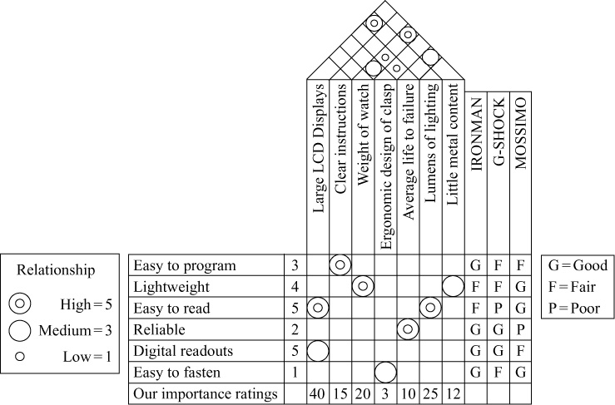

on the Web. This house includes features and comparisons for three options. Importance and rating of features are subjective and just developed for this example.
5.2 For an existing organization, the student should build a house of quality, entering the wants on the left and entering the hows at the top, similar to those shown in Problem 5.1. An example of a House of Quality for a lunch is shown in the text in “Solutions to Even Numbered Problems” (Appendix V).
5.3

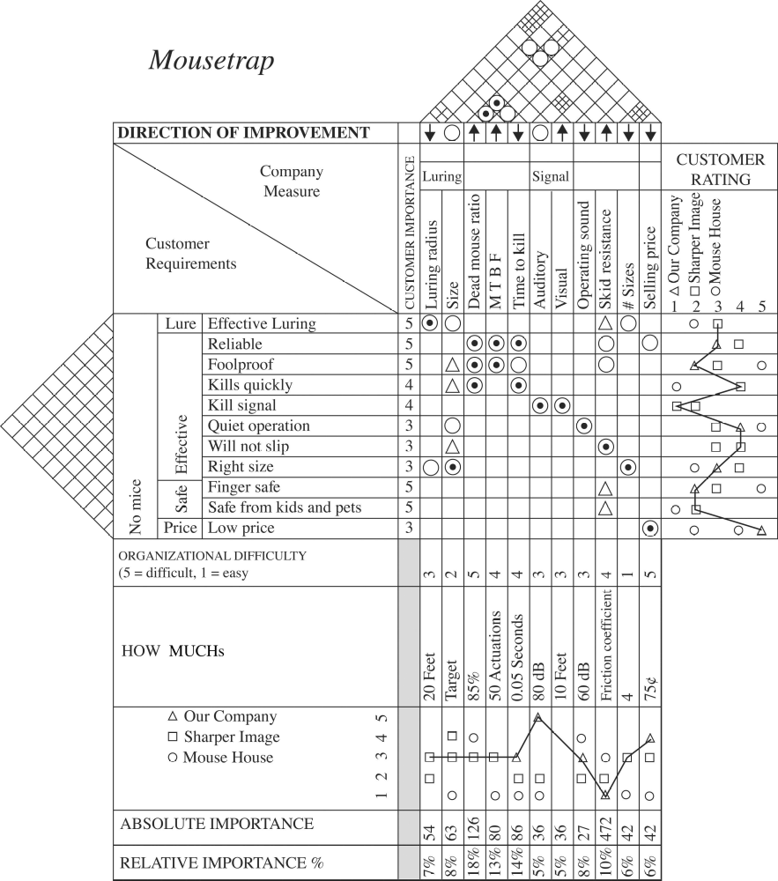

Source: American Supplier Institute; www.amsup.com/qfd/chart.html.

5.4 Individual answer for a bicycle customer in the style of Problem 5.1.
5.5 A typical bill-of-material is shown here:
(a)
Bill of Material for a Pair of Glasses in a Case
Part Number | Description | Quantity
G1001 | Sun Ban Large in Black Case | 1
CBL101 | Black Leather Case | 1
BF101 | Black Leather Front | 1
BB101 | Black Leather Back | 1
BC101 | Black Leather Pocket Clip | 1
SBL101 | Sun Ban Large Glasses | 1
SFA101 | Frame Assembly | 1
SF101 | Alloy Frame | 1
RL101 | Right Sun Ban Large Lens | 1
LL101 | Left Sun Ban Large Lens | 1
LTA101 | Left Temple Assembly—Large | 1
LT101 | Left Temple | 1
LTH101 | Left Temple Hinge | 1
LTE101 | Left Temple Ear Pad | 1
RTA101 | Right Temple Assembly—Large | 1
RT101 | Right Temple | 1
RTH101 | Right Temple Hinge | 1
RTE101 | Right Temple Ear Pad | 1
S1001 | Hinge Screws | 2

(b) There are obviously a very large number of possibilities, Quizno’s honey-bacon-turkey club, regular size, uses a toasted 6″ bun (white or wheat), two slices of bacon, three ounces of smoked sliced turkey, 2 Tbsp. shredded lettuce, 1 Tbsp. chopped onion, and 1/2 oz. honey-mustard sauce. It is wrapped in a 12″ square deli paper.

5.6 An assembly chart for the eyeglasses is shown below:
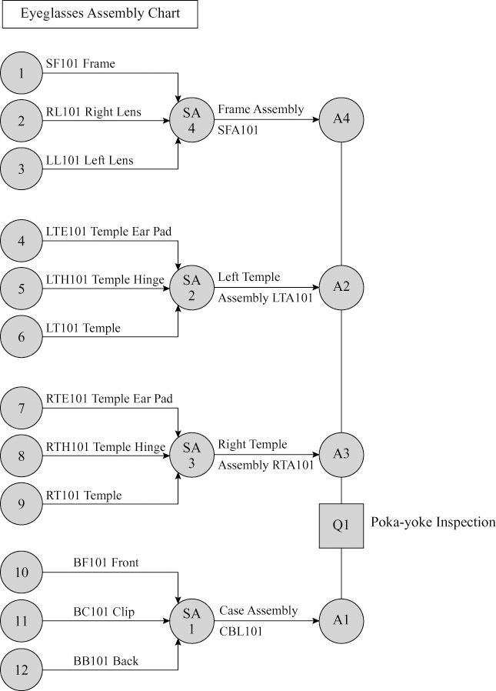
5.7 Services need documents for the transition to production. More creative students may have fun with this assignment, and you may have students who have actually done “cold calls” for a firm or the university and can discuss in detail the strong and weak points of the scripts they used. Some scripts provide only the high points of how to greet, warm up, ask, and close. Other scripts are very explicit and provide the exact wording, with phrases to be used to overcome objections.
5.8 Assembly chart for a table lamp:

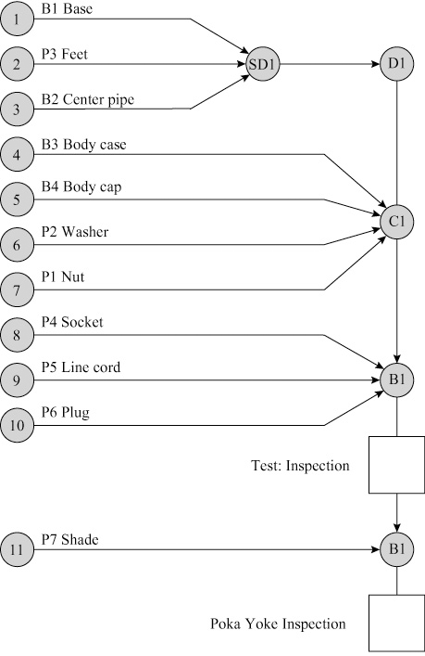
5.9
Product Alpha: 1,000 units × $2,500 = $2,500,000
Introductory
Product Bravo: 1,500 units × $3,000 = $4,500,000 Growth
Product Charlie: 3,500 units × $1,750 = $6,125,000 Decline
A product-by-value report such as this poses an interesting challenge for management. Here we have product Charlie, whose sales are declining producing the highest annual contribution to the firm. What can/should the firm do? What kind of product extensions, modifications, enhancements are possible to breathe new life into the product?
Products Alpha and Bravo appear to be doing well on modest sales. And because they are in the introductory and growth stages respectively, both may warrant more capacity and R&D. Product Bravo may also warrant a focus on more efficient production and supplier and distribution development.
5.10 Possible strategies:
Kindle 2 (growth phase):
■ Increase capacity and improve balance of production system
■ Attempt to make production facilities more efficient
Netbook (introductory phase):
■ Increase R&D to better define required product
characteristics
■ Modify and improve production process
■ Develop supplier and distribution systems
Hand calculator (decline phase):
■ Concentrate on production and distribution cost reduction
■ Attempt to develop improved product
■ Attempt to develop supplementary product
■ Unless product is of special importance to overall competitive strategy, consider terminating production

5.11
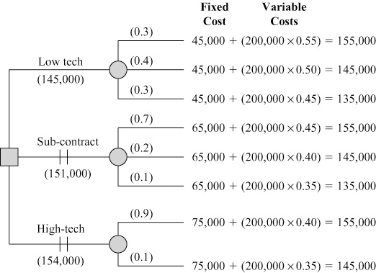

The firm should utilize the low technology approach for a cost of $145,000.
5.12
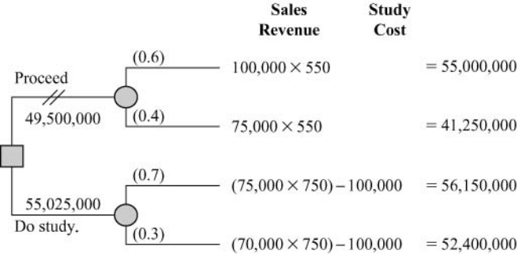

The company should complete the value analysis for an
expected payoff of $55,025,000.
5.13
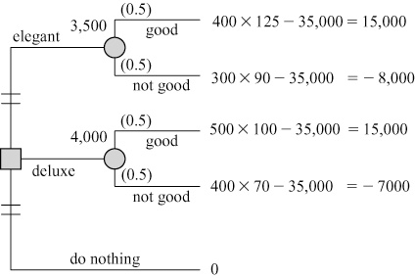

Produce the deluxe version; EMV is highest.
5.14
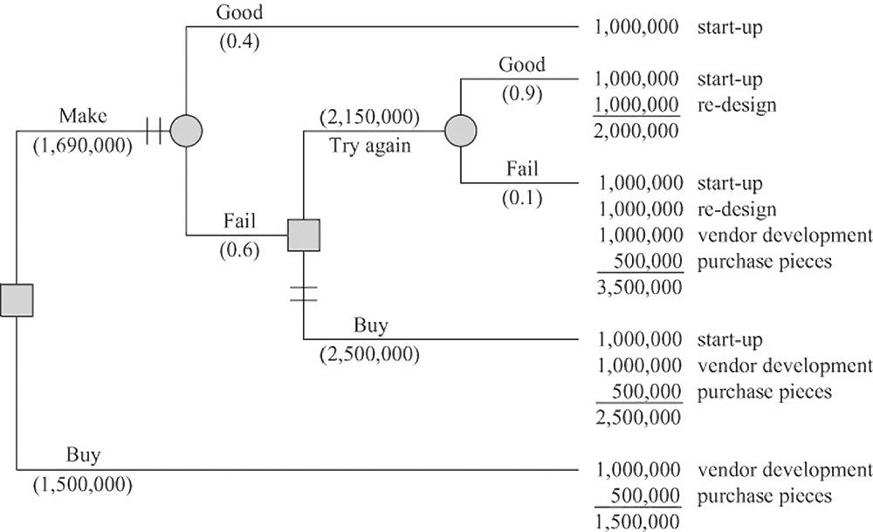

(a) The best decision would be to buy the semiconductors. This decision has an expected payoff (cost) of $1,500,000.
(b) Expected monetary value, minimum cost.
(c) The worst that can happen is that Ritz fails at its attempt to make semiconductors, ends up buying them instead, and spends $3,500,000.
The best that can happen is that they make the semiconductors and spend only $1,000,000.
5.15 The decision tree is shown here:

The joint design provides the lowest EMV and hence the lowest expected cost.
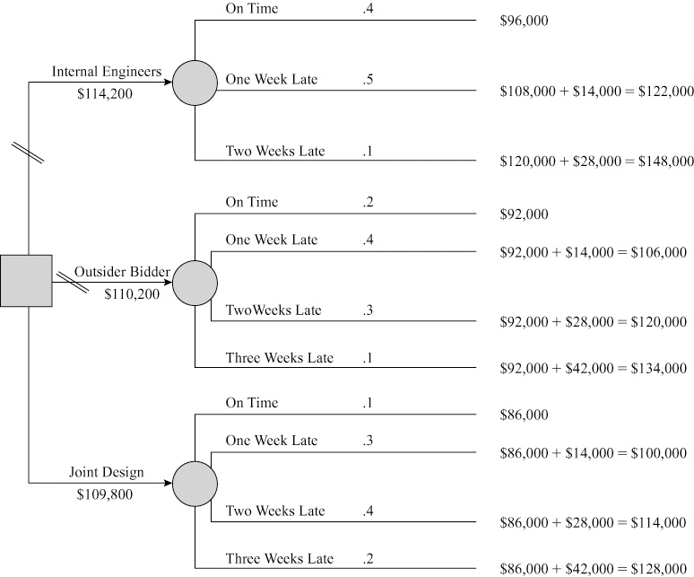

5.16 The modified decision tree and the new payoffs are shown. We have made a second decision on those branches where the yield was only 59 per 100 and have modified the payoffs by
adding the revenue and costs associated with the corrections of
5 units per 100. We then pruned those branches with the lowest payoff (which, in both cases, was the branch labeled “Do not correct”). Here are the EMV calculations:
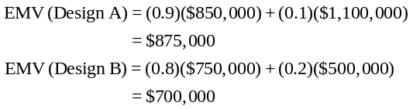
Using the high payoff branches, we conclude that the expected monetary values are $875,000 from Design A and $700,000 from Design B. Therefore, the decision when King Electronics has the option of correcting 5 units per 100 is to correct them and use Design A.
Decision Tree for Problem 5.16
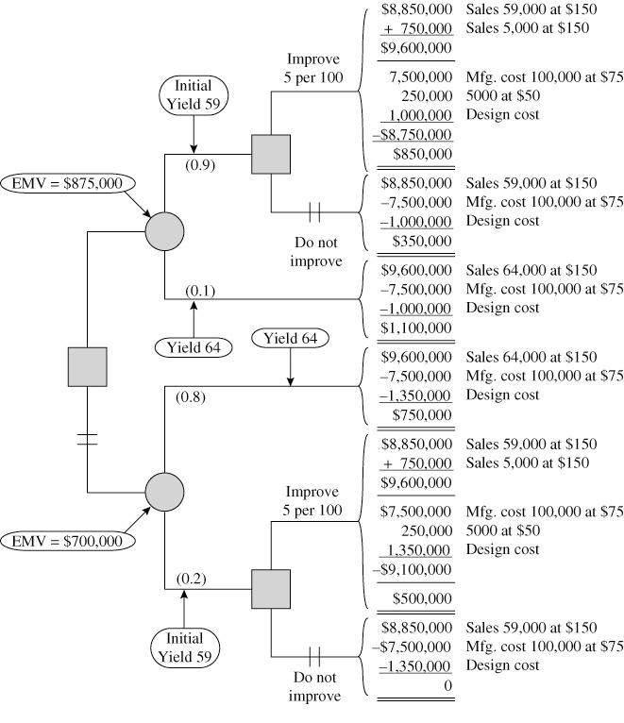

5.17 House of Quality Sequence for Ice Cream
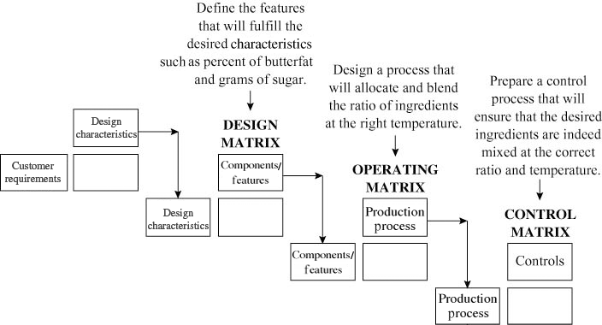

5.18
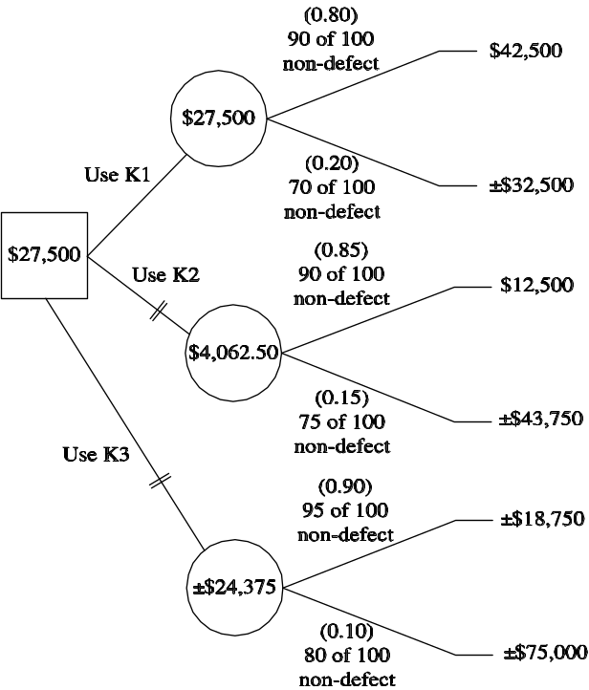

EMV: $27,500—use K1

Outcome calculations:
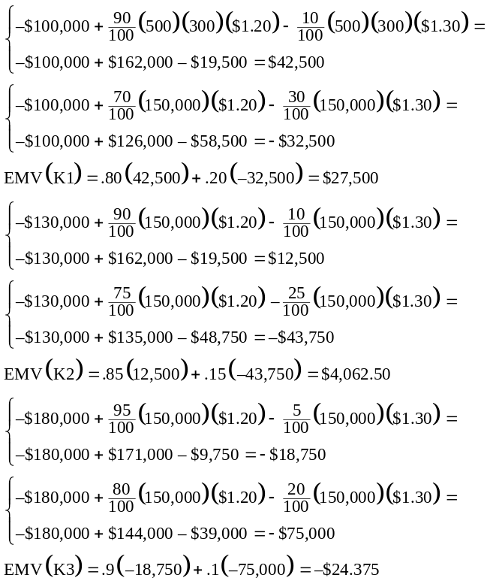

ADDITIONAL HOMEWORK PROBLEMS*
Solutions to Problems 5.19–5.25 that appear on our web site
www.pearsonglobaleditions.com/myomlab.
5.19 The answer should look something like the following

Bill of Materials for “Curried Couscous
Salad with Dried Cranberries”
Description | Quantity
Curried couscous salad with dried cranberries | 1
Salad | 1
Un-cooked couscous | 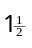cups
Dried cranberries | 1 cup
Frozen peas–thawed | 1 cup
Curry powder | tsp
Boiling water | 2 cups
Thinly sliced green onions | cup
Finely chopped fresh basil | cup
Canned chickpeas | 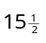oz
Dressing
Fresh lemon juice | cup
Grated orange ring | 1 tblsp
Water | 2 tsp
Olive oil | tblsp
Thawed orange juice concentrate | 1 tblsp
Black pepper | tsp
Garlic cloves, crushed | 4

5.20 ‘Product-by-value’ analysis for products A, B, C, D, E.

Individual |  |  | Total
Contribution |  |  | Contribution
C |  | Keep these | D
D |  |  | C
A, E |  | Investigate | B
B |  | these for | A
 |  | replacement | E

5.21 Bill-of-material for a wooden pencil with eraser.

Description | Quantity
Pencil | 1
Wood half | 2
Graphite rod | 1
Band | 1
Eraser | 1
Yellow paint | 2 grams

*Note to instructor: To broaden the selection of problems, these are also available to you and your students.
5.22 Bill of material for a table

Table
Table | 1
Table Top | 1
Frame:
Back | 1
Front | 1
Left Side | 1
Right Side | 1
Bracket | 4
Bolt | 4
Washer | 4
Nut | 4
Legs:
Legs | 4
Casters | 4

5.23 A bill of material for a computer mouse (GeniMouse) is shown below.

Bill of Material for GeniMouse
Part Number | Description | Quantity
GM1001 | GeniMouse | 1
SC004 | Phillips Head No.12 0.5 inch. Screw | 1
TA101 | Top Mouse Assembly | 1
CB101 | Center Button | 1
CBC101 | Center Button Clip | 1
RB101 | Right Button | 1
LB101 | Left Button | 1
PB101 | Palm Base | 1
BA101 | Base Assembly | 1
IA101 | Idler Assembly | 1
IS101 | Idler Spring | 1
IR101 | Idler Roller | 1
MB101 | Ball | 1
BW101 | Base Ball Washer | 1
BP101 | Base Rest Pads | 5
BA101 | Board Assembly | 1
CA101 | Cable Assembly | 1
DB101 | Digital Board | 1
CW101 | Control Wheel | 2
GML101 | GeniMouse Label | 1

5.24 Sample bill of materials for a mechanical pencil

ID | Description | Quantity
A1 | Mechanical Pencil | 1
B1 | Top half | 1
C1 | Top casing | 1
C2 | Pocket clip | 1
C3 | Plunger cap | 1
C4 | Plunger | 1
C5 | Small spring | 1
C6 | Brass guide | 1
C7 | Brass Clamp | 1
C8 | Eraser | 1
B2 | Lower half | 1
C9 | Bottom casing | 1
C10 | Guide | 1
C11 | Rubber Finger Grip | 1
An implication (not necessarily correct) in constructing the bill of materials in this fashion is that all assembly operations will be of a similar nature. In the present instance, the assembly of the top casing and the pocket clip would probably be mechanized, while the remaining assembly steps might be done by hand.

5.25 The decision tree is:

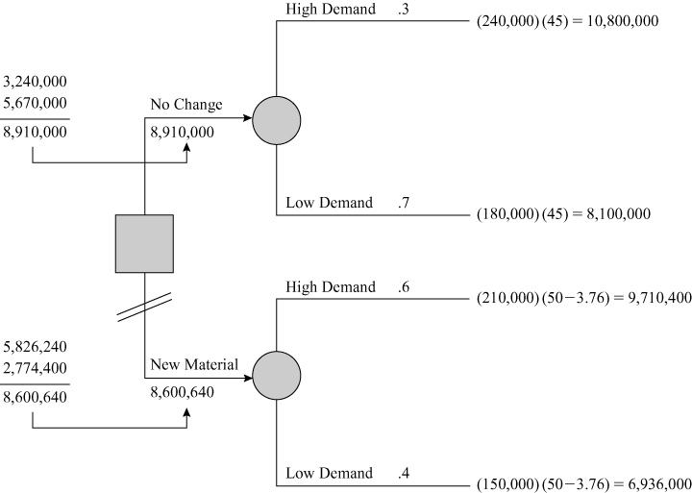

The EMV is maximized when using the existing material.

Case Study
TEMSA GLOBAL’S PRODUCT STRATEGY
- What is the product strategy of Temsa Global in 2009? How is it different from the product strategy in 1984? What organizational changes are required to support this shift?

The product strategy of Temsa Global in 2009 is characterized by modular design and green design. The modular design helps in offering customized products to different customer segments in different countries, while the green design is aimed at reducing the weight of the locomotive and introducing hybrid technologies in order to reduce energy consumption. In contrast, the strategy in 1984 is simple manufacturing as per the specifications of Mitsubishi. The shift from the simple strategy of 1984 to the innovative strategies in 2009 necessitates several organizational changes. A higher investment in R&D, collaboration with European partners such Arriva, investments in mass customization infrastructure and improving service network.

- What are the possible advantages of investing in the R&D center for advanced technologies? Discuss implications, considering the changing perceptions and demands of consumers.

For a progressive company, regular investment in R&D is a must because requirements of customers change over time, and, design and production should follow these changes. In addition, requirements of the society also change, for example, in the form of increased environmental regulations by the governments aimed at protecting the environment. Competitors also invent new products regularly, and hence to stay ahead of the completion, investment in R&D is a must.

- What should be the focus of Temsa Global in supporting their market-driven product strategy and customized designs?

Temsa should aim to improve its infrastructure to support its fast growth. Customer service is an important component of the new global leadership strategy adopted by the company, and sufficient investments in developing an adequate service network that covers markets with seemingly different characteristics are needed. Employees need to be trained to improve their service culture.
Video Case Study
PRODUCT DESIGN AT REGAL MARINE
The 7-minute video available from Pearson Education, filmed specifically for this text, supplements the written case.
1. The concept of product life cycle applies to Regal Marine because Regal is constantly under pressure to introduce new products—and those products have life cycles of relatively few years. As the video suggests, it is a matter of typically less than five years before a boat is out of style and its life cycle terminated. This is a long life cycle compared to a newspaper or magazine, but if you are the production manager it seems rather short.
2. Regal Marine uses a strategy of product differentiation, which constantly introduces new products with new innovations and new styling to stay competitive in the luxury performance boat market.
3. The cost and time saving at Regal Marine through use of CAD is typical of the use of CAD everywhere. It allows a variety of designs and styles to be tested very economically. The ratio of savings of engineering talent is about four to one. Most importantly, it allows them to be creative economically and rapidly.
4. The payoff from CAD is not only evident in efficiency, creative designs, and styling but by production of the code necessary for the numerical machines, such as the machines used to make the plugs in Washington state and for those applications of the numerical control machines at Regal Marine. CAD also provides, as a by-product, very effective and comprehensive documentation of design variables.

